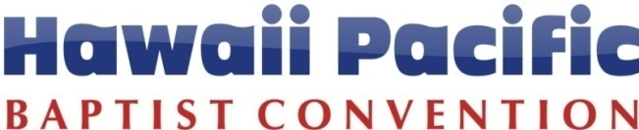
Michael “Bong” Abagon, Prayer & Evangelism
Direct: (808) 356-8341
Cell: 741-6294
michael@hpbaptist.net
2017 EVANGELISM FUNDING REPORT (2017-1):
Please attach pictures with this report
Name: _____________________ Your Email: __________________ Date: ______________
Church Name: _________________________________________________________________
Project: __________________ ________________ Date of Project: ___________________

How many unchurched were reached? _______ | Number of results from these encounters?
How many unchurched were ministered to? | - ___ No decision
- ___ prayed for | - ___ Accepted Jesus
- ___ group gospel presentation | - ___ Recommitment
- ___ one-on-one gospel presentation | - ___ Made a follow up appointment
- ___ invited to church | - ___ Others (specify) ___________________________

Share what God did in your event (use another page if necessary):
Share what follow up was or will be used (use another page if necessary):

On a scale from 1 to 5, rate your group on the following items.
1 = Strongly Disagree 2 = Disagree 3 = Agree 4 = Strongly Agree 5 = Couldn’t agree more!
All members contributed equally to the project. | 1 | 2 | 3 | 4 | 5
Prayer prepared this evangelistic event. | 1 | 2 | 3 | 4 | 5
Planning preparation was adequate. | 1 | 2 | 3 | 4 | 5
The number of expected prospects came. | 1 | 2 | 3 | 4 | 5
A follow up system is in place for this event. | 1 | 2 | 3 | 4 | 5
This evangelistic event was over all successful. | 1 | 2 | 3 | 4 | 5

Churches in the Pacific Impacting the World
2042 Vancouver Drive, Honolulu, Hawaii 96822-2491
Phone: (808) 946-9581 / Fax: (808) 941-2309 / Website: www.hpbaptist.net

