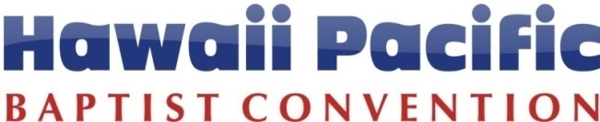
Michael “Bong” Abagon, Prayer & Evangelism
Direct: (808) 356-8341
Cell: 741-6294
michael@hpbaptist.net
2017 EVANGELISM FUNDING REPORT (form 2017-1)
Please attach pictures with this report
Name: Email: Date:
Church Name:
Project: Date of Project:

How many unchurched were reached? | Number of results from these encounters?
How many unchurched were ministered to? | - No decision
- prayed for | - Accepted Jesus
- group gospel presentation | - Recommitment
- one-on-one gospel presentation | - Made a follow up appointment
- invited to church | - Others (specify)

Share what God did in your event:
Share what follow up was or will be used:

On a scale from 1 to 5, rate your group on the following items.
1 = Strongly Disagree 2 = Disagree 3 = Agree 4 = Strongly Agree 5 = Couldn’t agree more!
All members contributed equally to the project. | 1 | 2 | 3 | 4 | 5
Prayer prepared this evangelistic event. | 1 | 2 | 3 | 4 | 5
Planning preparation was adequate. | 1 | 2 | 3 | 4 | 5
The number of expected prospects came. | 1 | 2 | 3 | 4 | 5
A follow up system is in place for this event. | 1 | 2 | 3 | 4 | 5
This evangelistic event was over all successful. | 1 | 2 | 3 | 4 | 5

Churches in the Pacific Impacting the World
2042 Vancouver Drive, Honolulu, Hawaii 96822-2491
Phone: (808) 946-9581 / Fax: (808) 941-2309 / Website: www.hpbaptist.net

